**Password update:** [**https://citria.org/admin/change-password/rutujakhedkar98@gmail.com**](https://citria.org/admin/change-password/rutujakhedkar98@gmail.com)

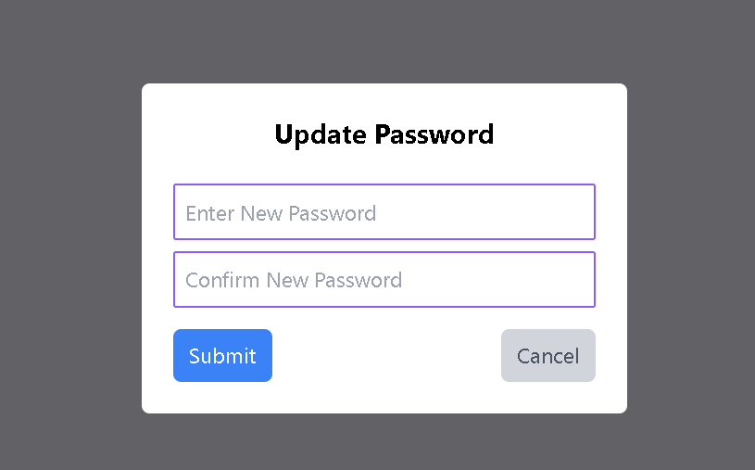

The UpdatePasswordByAdmin component is designed to allow administrators to update the password for a specific user. Let's break down its structure and features:

Routing Parameters:

Utilizes the useParams hook from react-router-dom to retrieve the email parameter from the URL. This parameter represents the email of the user for whom the password is being updated.

State Management:

Manages the form input values using the useState hook.

Initializes passwords state with newPassword and confirmPassword.

Form Handling:

Defines a handleResetPassword function to handle the form submission.

Validates that both the new password and confirm password fields are filled, and the new password has a minimum length of 6 characters.

Makes an asynchronous request to the server using Axios to update the user's password.

Displays success or error messages using the showToast function from the context.

Navigates back to the list of all users (/admin/all-users?page=1) upon successful password update.

Styling and UI Elements:

Uses Tailwind CSS classes for styling, including form input styling, button styles, and layout.

Loading Spinner:

Displays a loading spinner (Spinner component) while the password update request is in progress.

Cancel Button:

Provides a "Cancel" button that redirects administrators to the list of all users without making any changes.

Modal Layout:

Renders a modal layout with a semi-transparent background (bg-black/60) to focus attention on the password update form.

Centrally positions the form inside the modal for a clean and user-friendly interface.

Page Title:

Sets the page title to "Update Password - Admin" using the PageTitle component.

In summary, the UpdatePasswordByAdmin component serves as a secure and user-friendly interface for administrators to update the password of a specific user. It follows best practices for form validation and provides feedback to the user through messages and loading spinners.